PROJECT REPORT

1.INTRODUCTION:

1.1 OVERVIEW:

Manage different aspect of hospital operations efficiency with easy access to critical patient information.

1.2 PURPOSE:

Zoho books is your one-stop platform for managing your accounting tasks and your organizing transactions.

It’s a single secure location to keep up with your company’s bills and invoices, reconcile your bank statements, control your spending, oversee projects, and eliminate GST compliance worries.

2.PROBLEM DEFINITION DESIGN THINKING:

2.1 EMPATHY MAP:

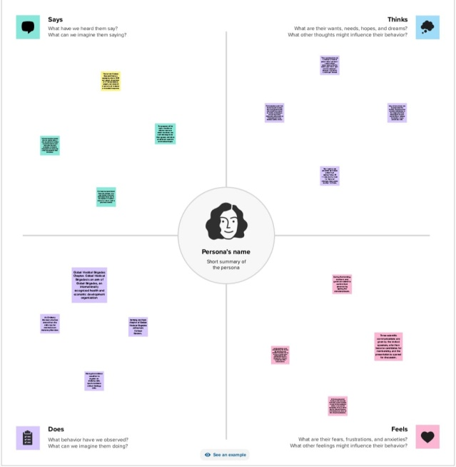

2.2 IDEATION AND BRAINSTORMING MAP:

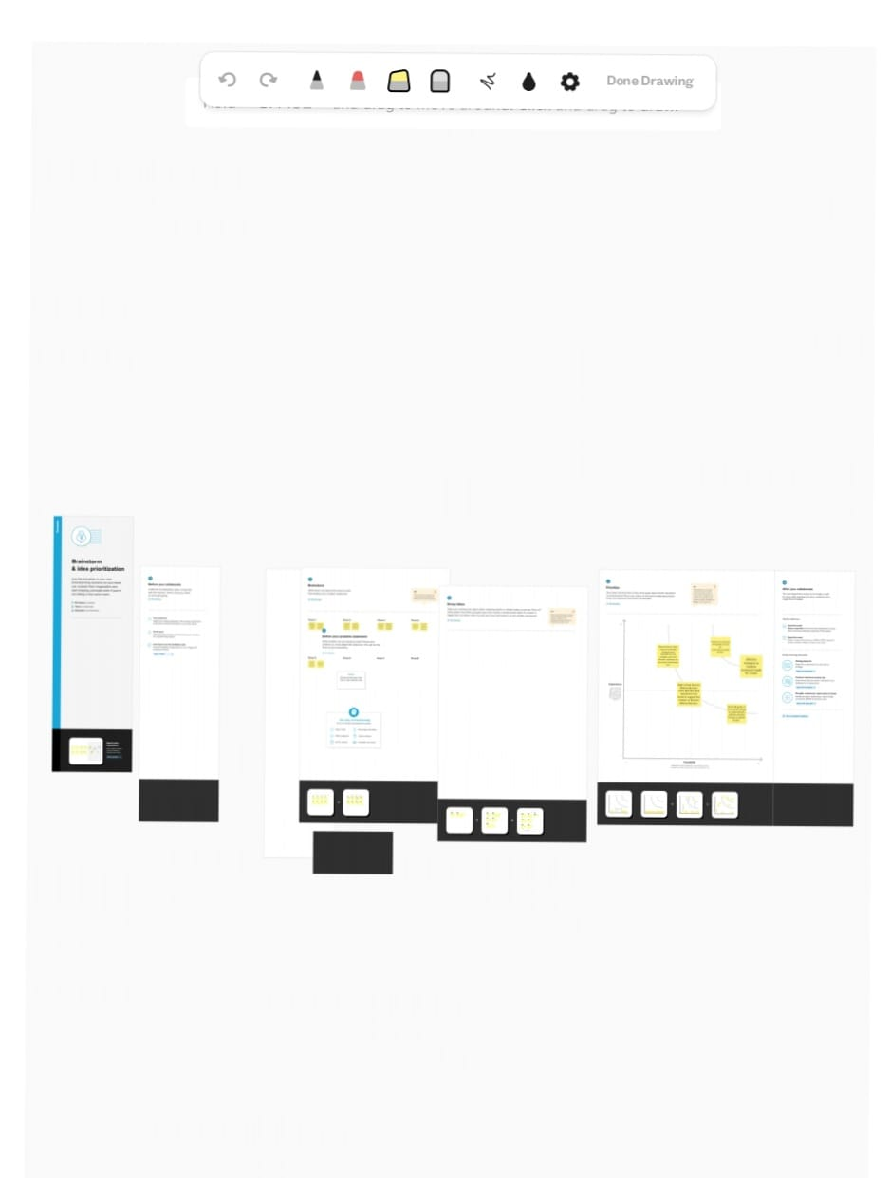

3.RESULT:

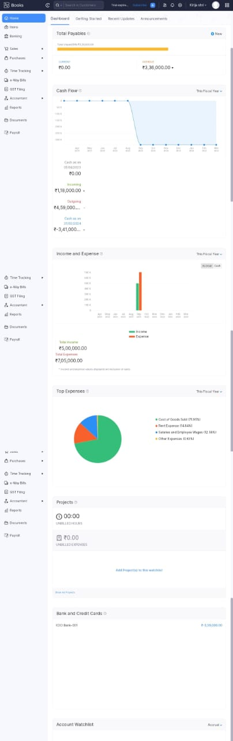

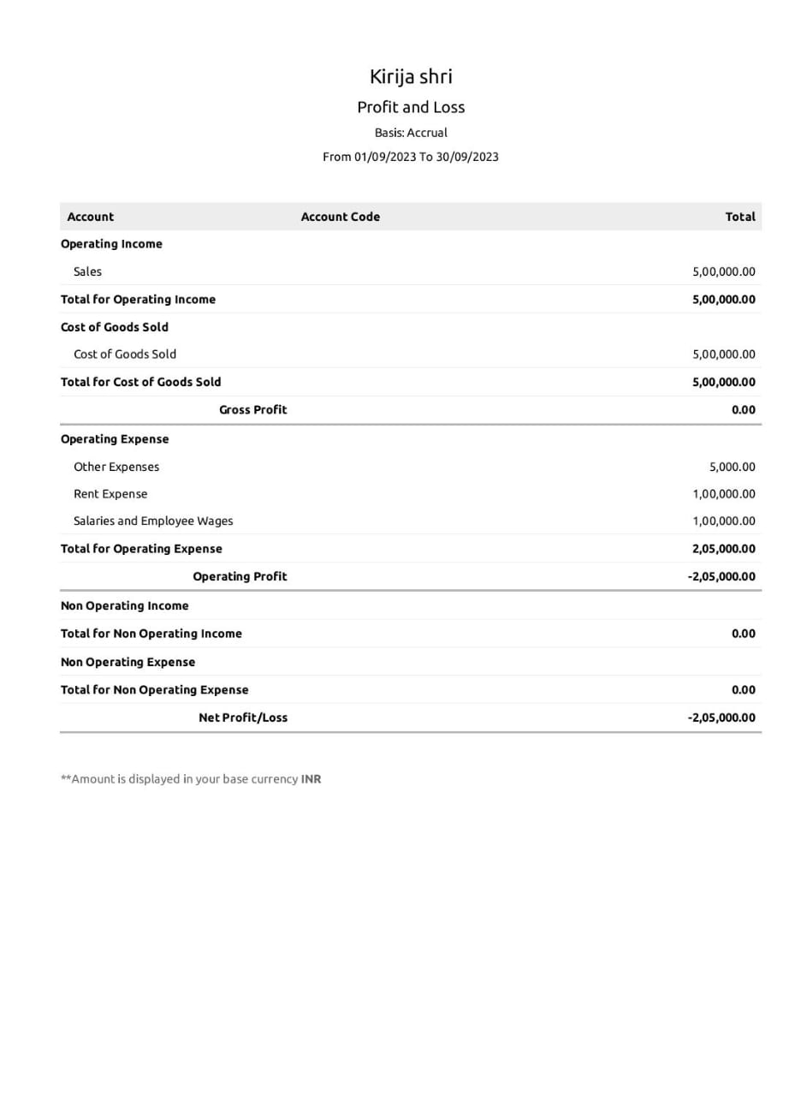

4.ADVANTAGES AND DISADVANTAGES:

It allows you to manage your project from budgeting to logging them and invoicing customer effectively.

All zoho books plans set a maximum number of invoices you can issue per year.

5.APPLICATION:

Organize multiple departmental reports of a patient within a Team Folder, enabling teams to efficiently coordinate. Gather medical history, Insurance details scanned reports, and issued prescriptions to quickly draft a discharge summary.

6.CONCLUSION:

This can be a powerful tool to help health care organizations improve their processes and streamline their operation as well as provide real time insights into hospital performance.

7.FUTURE SCOPE:

We are excited to bring a refreshed design along with enhancements to the users interface in zoho books.